#CTS NURTURE_4.0 JAVA FSE:  
# WEEK 2

1. IF-THEN-ELSE: Check if number is positive, negative, or zero

DECLARE

num NUMBER := &num;

BEGIN

IF num > 0 THEN

DBMS_OUTPUT.PUT_LINE('The number is Positive');

ELSIF num < 0 THEN

DBMS_OUTPUT.PUT_LINE('The number is Negative');

ELSE

DBMS_OUTPUT.PUT_LINE('The number is Zero');

END IF;

END;

/

**OUTPUT:**

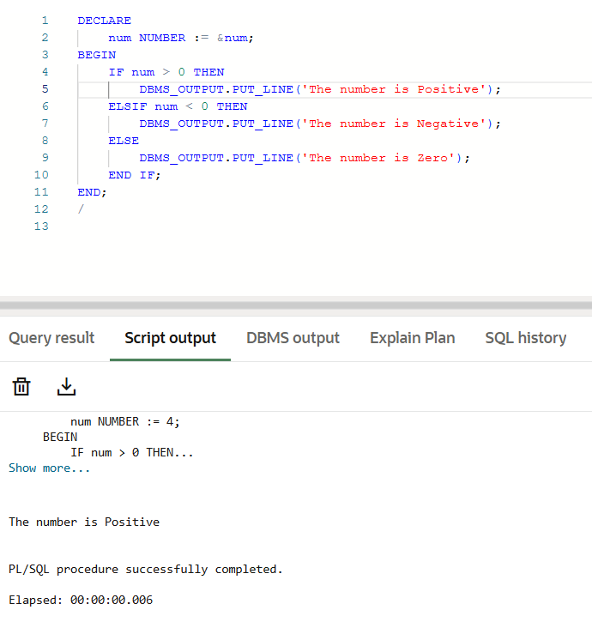

1. SIMPLE LOOP with EXIT: Print numbers 1 to 5

DECLARE

i NUMBER := 1;

BEGIN

LOOP

EXIT WHEN i > 5;

DBMS_OUTPUT.PUT_LINE('Number: ' || i);

i := i + 1;

END LOOP;

END;

/

**OUTPUT:**

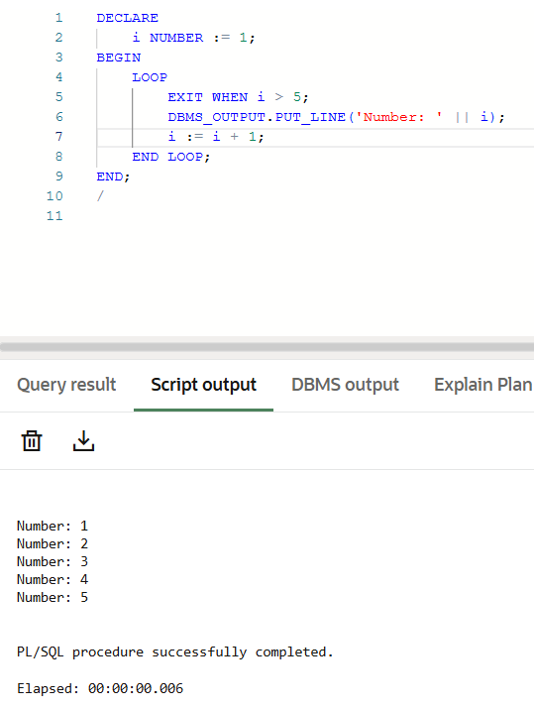

1. WHILE LOOP: Find the sum of first 10 natural numbers

DECLARE

i NUMBER := 1;

sum NUMBER := 0;

BEGIN

WHILE i <= 10 LOOP

sum := sum + i;

i := i + 1;

END LOOP;

DBMS_OUTPUT.PUT_LINE('Sum = ' || sum);

END;

/

**OUTPUT:**

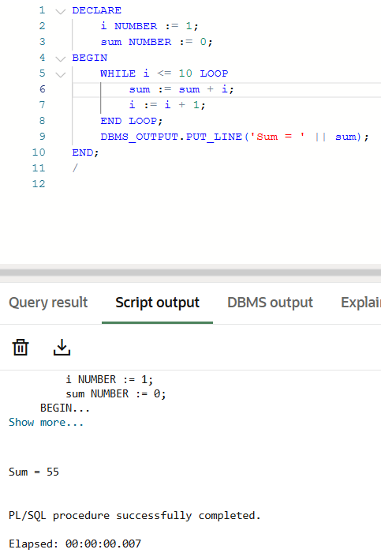

1. FOR LOOP: Print squares of numbers from 1 to 5

BEGIN

FOR i IN 1..5 LOOP

DBMS_OUTPUT.PUT_LINE('Square of ' || i || ' is ' || i*i);

END LOOP;

END;

/

**OUTPUT:**

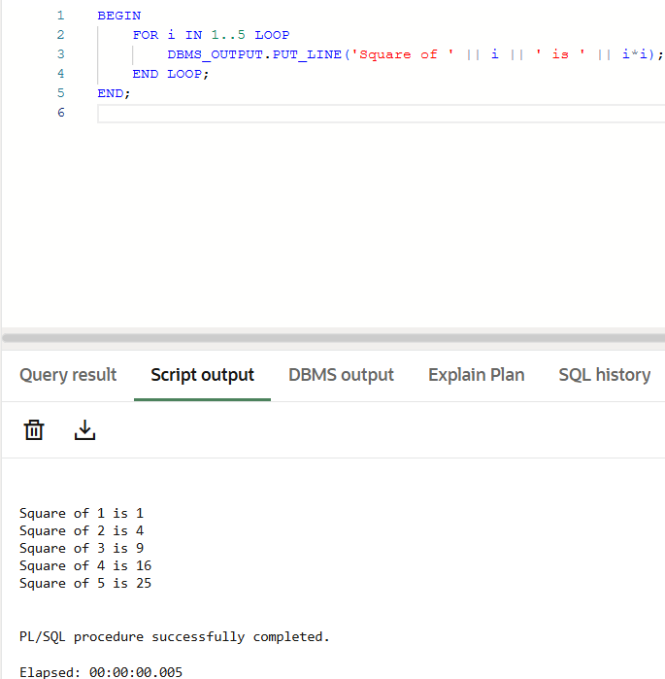

5. Nested IF inside FOR LOOP: Display even and odd numbers

BEGIN

FOR i IN 1..10 LOOP

IF MOD(i, 2) = 0 THEN

DBMS_OUTPUT.PUT_LINE(i || ' is Even');

ELSE

DBMS_OUTPUT.PUT_LINE(i || ' is Odd');

END IF;

END LOOP;

END;

/

**OUTPUT:**  
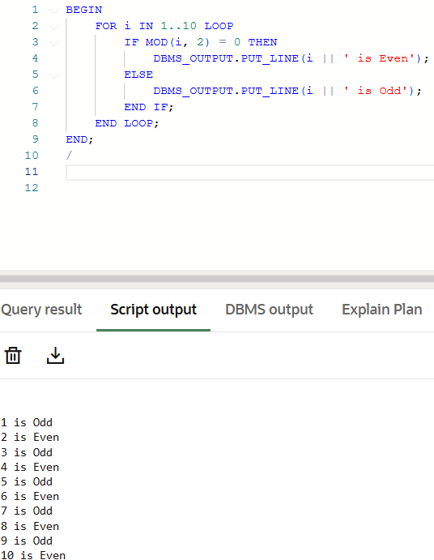

1. EXIT WHEN inside LOOP: Find factorial of a number

DECLARE

num NUMBER := &num;

i NUMBER := 1;

fact NUMBER := 1;

BEGIN

LOOP

EXIT WHEN i > num;

fact := fact * i;

i := i + 1;

END LOOP;

DBMS_OUTPUT.PUT_LINE('Factorial of ' || num || ' is ' || fact);

END;

/

**OUTPUT:**

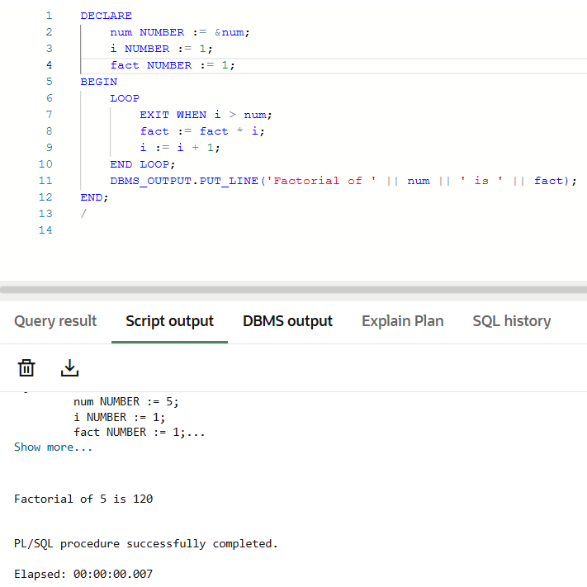

1. Nested LOOP: Multiplication table for 1 to 5

BEGIN

FOR i IN 1..5 LOOP

DBMS_OUTPUT.PUT_LINE('Table of ' || i);

FOR j IN 1..10 LOOP

DBMS_OUTPUT.PUT_LINE(i || ' * ' || j || ' = ' || i*j);

END LOOP;

DBMS_OUTPUT.PUT_LINE('------------------');

END LOOP;

END;

/

**OUTPUT:**

